|  |  |
| --- | --- |
|  | YEAR 11 PHYSICS  SEMESTER 2 2005 |

**Name:_________________________ Teacher: ________________**

**TIME ALLOWED FOR THIS PAPER**

Reading time before commencing work: Ten minutes

Working time for paper: Three hours

**MATERIAL REQUIRED/RECOMMENDED FOR THIS PAPER**

*TO BE PROVIDED BY THE SUPERVISOR*

This Question/Answer Booklet

Physics Formulae and Constants Sheet

Sheet of standard graph paper

*TO BE PROVIDED BY THE CANDIDATE*

*Standard Items:* Pens, pencil, eraser, correction fluid and ruler

*Special Items:* Drawing instruments, templates and calculators satisfying the conditions set by the Curriculum Council.

**IMPORTANT NOTE TO CANDIDATES**

**No other items may be taken into the examination room.**

**It is your responsibility to ensure that you do not have any unauthorised notes or other items of a non-personal nature in the examination room. If you have any unauthorised material with you hand it to the supervisor BEFORE reading any further.**

**STRUCTURE OF PAPER**

|  |  |  |  |  |
| --- | --- | --- | --- | --- |
| Section | No. of questions | No. of questions to be attempted | No. of marks out of 200 | Proportion of examination total |
| A: Short Answers | 15 | ALL | 60 | 30% |
| B: Problem Solving | 7 | ALL | 100 | 50% |
| C: Comprehension and Interpretation | 2 | ALL | 40 | 20% |

**INSTRUCTIONS TO CANDIDATES**

Write your answers in the spaces provided beneath each question. The value of each question (out of 200) is shown following each question.

The Physics Data Sheet must also be submitted with your exam.

Calculators satisfying the conditions set by the Curriculum Council may be used to evaluate numerical answers.

Answers to questions involving calculations should be evaluated and given in decimal form. Quote the final answer to no more than three significant figures. Despite an incorrect final result, credit may be obtained for method and working, provided these are clearly and legibly set out.

Questions containing specific instructions to **show working** should be answered with a complete, logical, clear sequence of reasoning showing how the final answer was arrived at; correct answers which do not show full working will not be awarded full marks.

Questions containing the instruction **estimate** may give insufficient numerical data for their solution. Students should provide appropriate figures to enable an approximate solution to be obtained.

**SECTION A: Short Answers**

Marks Allotted: 60 marks out of total of 200 marks (30%)

Attempt **ALL** 15 questions in this section. Each question is worth 4 marks. Answers are to be written in the space below or next to each question.

1. Jane has been asked to give a short talk on sea breezes. Listed below are some key parts of her speech. Help her prepare the speech by choosing the best alternative for the options given.  
     
   In the following indicate the answer by circling the best choice from the bolded options.

*“During hot summer days***, [radiant/convective]** *energy from the sun heats the land and sea. The land, however, has a* **[lower/higher]** *specific heat capacity than the sea and soon has a* **[higher/lower]** *temperature than the water. The air near the ground becomes hot as a result of* **[convection/conduction]***. As the air gets hot, it* **[contracts/expands]**, *becoming* **[less/more]** *dense than the air over the sea. The air over the* **[land/sea]** *rushes in towards the***[sea/ land]**, *replacing the rising warm air, causing what is know as a sea breeze.”*

1. 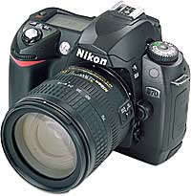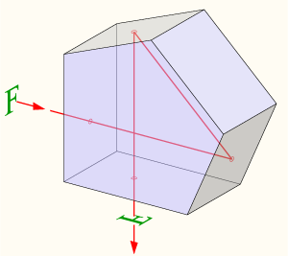A pentaprism is a five-sided reflecting prism used to deviate a beam of light by 90° in a single lens reflex camera. The beam reflects inside the prism twice, allowing the transmission of an image through a right angle without inverting it as an ordinary right-angle prism would. The diagram below shows a ray of light being reflected inside a pentaprism of refractive index 1.34.  
     
     
   Is the ray inside the pentaprism being reflected due to total internal reflection? Explain.
2. The Cassini space probe (mass 5.5 x 104 kg) was successfully launched onboard a TITAN IV rocket from Cape Canaveral on October 15, 1997 on a voyage to Saturn. The diagram below shows the deployed space probe moving at a constant velocity of 890 ms-1 towards **A**.To change course, a sideways force is produced by firing the thruster. This increases the velocity towards **B** from 0 to 60 ms-1 in 25 s. Determine the magnitude of the resultant velocity after 25 s

**A**

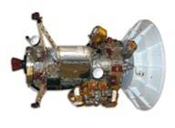

**B**

**Thruster**

1. In terms of the energy of particles, explain why a sample of a volatile liquid such as methylated spirits, cools as the liquid evaporates?
2. A two resistor voltage divider is often used to supply a voltage that is different from the power supply. In application, the output voltage depends upon the resistance of the load it drives. The picture at right below shows a typical voltage divider, with connections made across different pin combinations resulting in different potential differences. The diagram below at left shows a simplified circuit diagram of the voltage divider

|  |  |
| --- | --- |
| For this circuit , VIN = 30.0 V, R1 = 5.0 kΩ and the output voltage VBC OUT = 6.0 V |  |

Calculate the value of the resistance R2 in the circuit above?

1. Suppose in the laboratory you wanted to construct the circuit as shown in the diagram in question 5, but only have 20 kΩ resistors to work with. Explain how you could use 20kΩ resistors to create the equivalent resistance as a 5 kΩ resistor. Include a sketch to show the connections between the appropriate number of 20 kΩ resistors.
2. When referring to radiation dosage, gamma (γ) radiation and alpha (α) radiation have different quality factors.  
   1. State which type of radiation has the larger quality factor.
   2. Explain why, for the same absorbed dose, the radiations have different effects.
3. The diagram below shows a trampoline. Explain, in terms of momentum, why you do not hurt yourself when falling into the mat, but you would if you missed the mat and hit the ground?  
     
   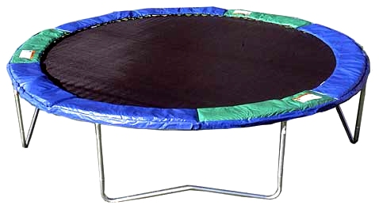
4. In terms of reflection and absorption of light, explain how the print on this page appears black on a white background.
5. The football commentator says "Going into the half time break, the Dockers have the *momentum*." The headlines declare "Fremantle Gaining *Momentum*." The coach *pumps* up his team at half-time, saying "You have the *momentum*; the critical need is that you use that *momentum* and bury them in this third quarter." Compare this description of momentum with your understanding of what we mean when we talk about momentum in physics.
6. Sodium-24 has a half life of 15 hours. A 45.0 g sample is flushed into a pipe line. How much will remain unchanged after one day?
7. Sketch the electric field that exists around a single isolated positive charge and use this diagram to explain what an electric field actually is?
8. The back of a Western Power electricity bill is shown below. Study the bill and answer the following questions.

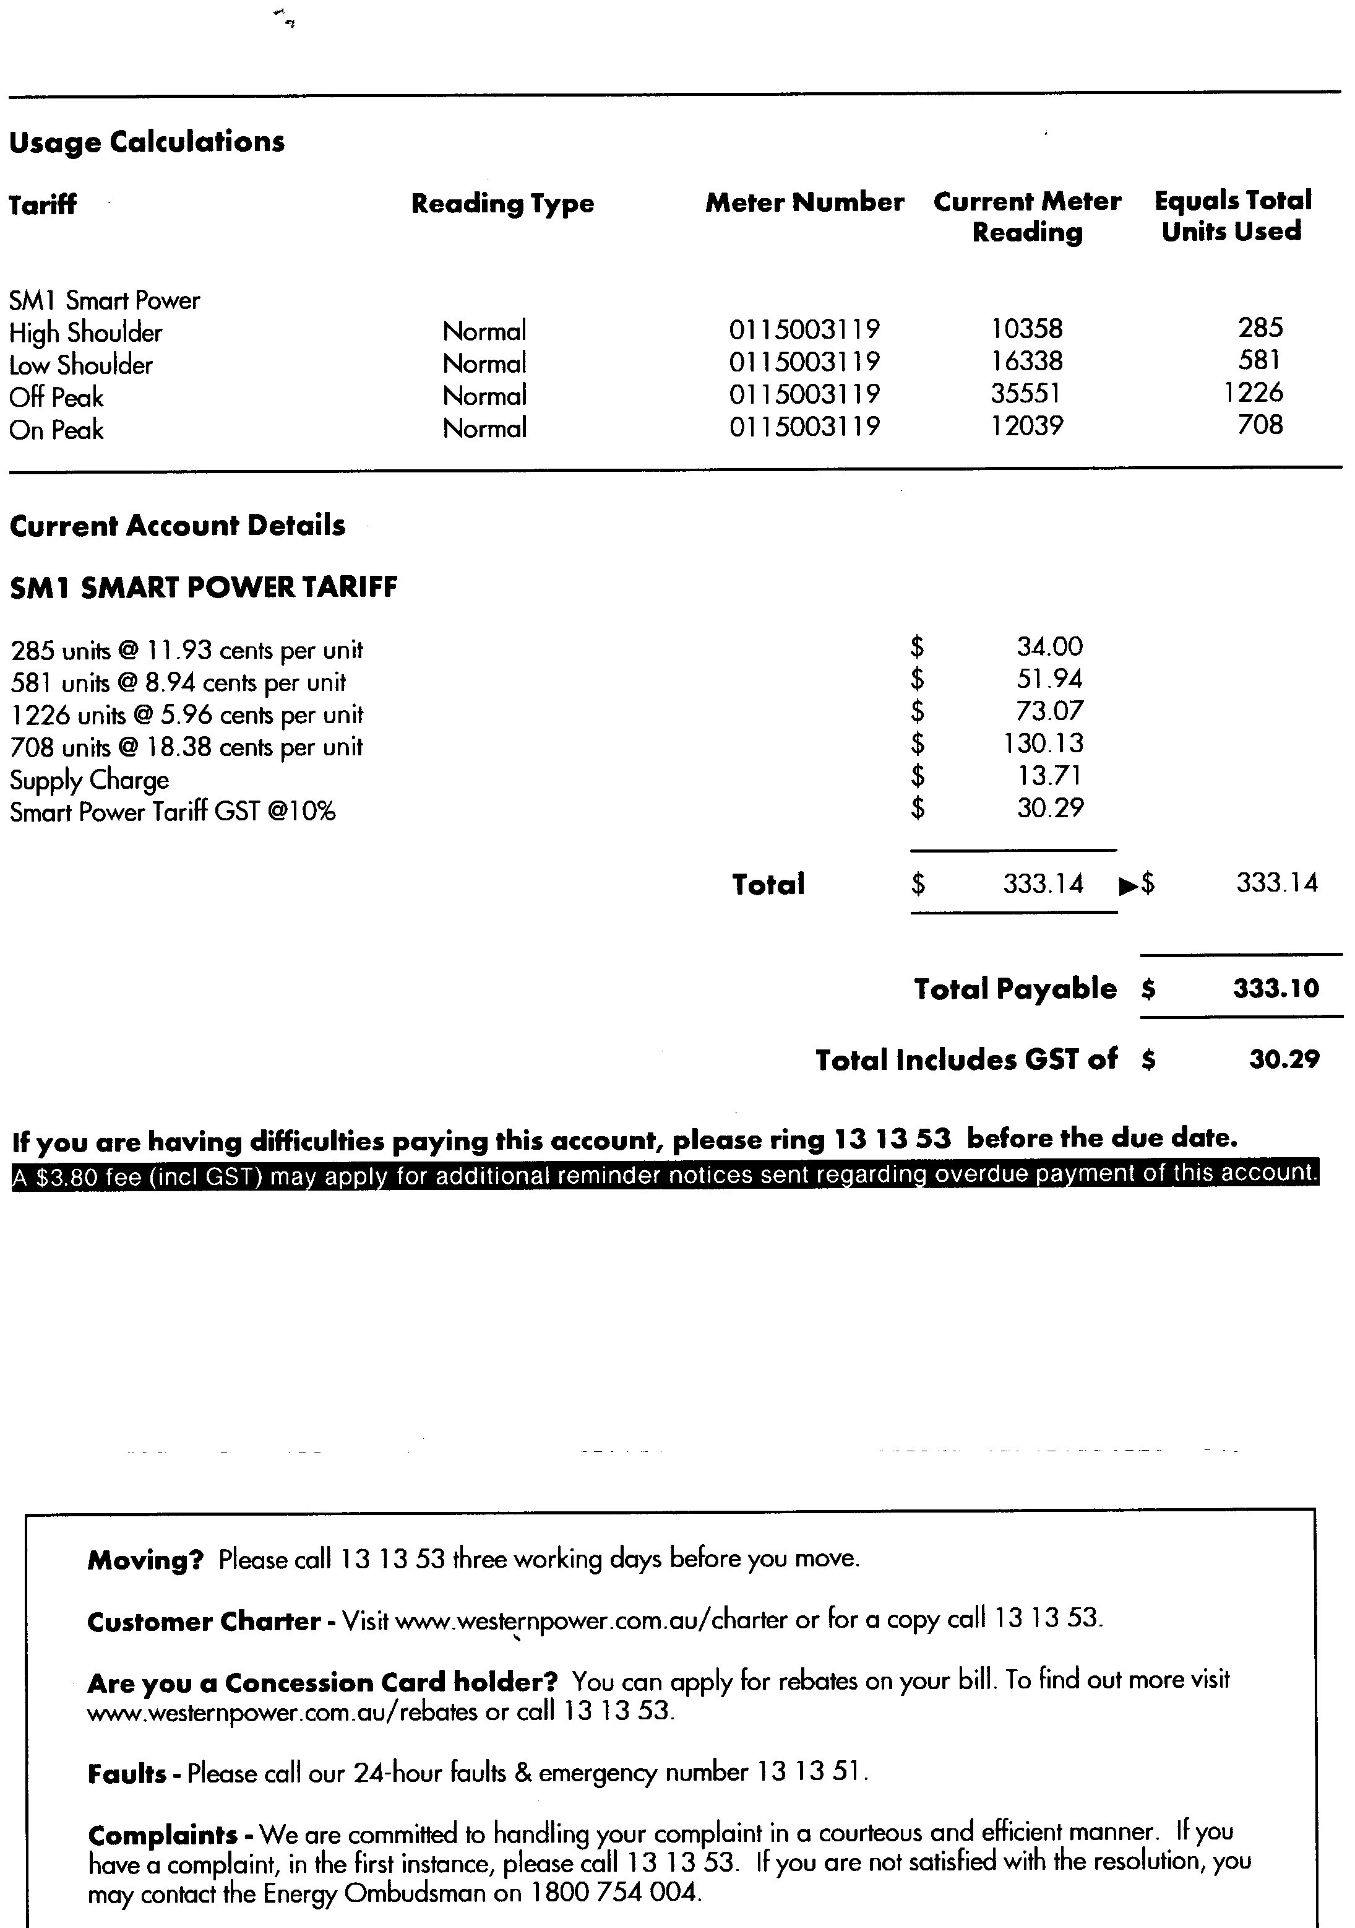

* 1. What is meant by the word ‘unit’ in this bill?
  2. Why does Western Power charge different rates depending on when the electricity is used (i.e. off peak and on peak)?

1. Sam repairs the cord on an electric kettle, but he mistakenly swapped the active and the neutral around. Is the kettle still capable of heating water and is it safe.   
   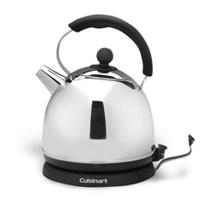
2. 1. What are radioisotopes?
   2. Describe one medical and one non medical use of radioisotopes.

**THIS PAGE HAS BEEN LEFT INTENTIONALLY BLANK**

**SECTION B: Problem Solving**

**Marks Allotted: 100 marks out of total of 200 marks (50%)**

### This section contains 7 questions. You should answer **ALL** of the questions and show **full working**.

Answer all questions in the spaces provided.

1. **[10 marks]**  
     
   On a school ski trip, a mini-bus transports passengers between the car park and the ski centre. The bus starts from the car park and travels north to the ski centre, drops off the passengers and returns to the car park. The velocity–time graph for the bus journey is given below.

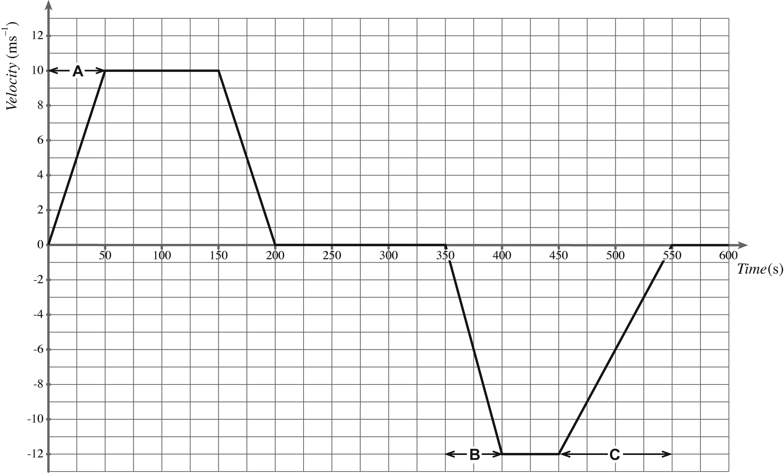

**Time (s)**

**Velocity**   
**(ms-1)**

* 1. The time taken by the bus to travel from the car park to the ski centre is 200 seconds. From the graph, calculate the distance travelled by the bus from the car park to the ski centre.  
      **[2 marks]**
  2. From the graph, show that the acceleration of the bus during section A of its journey is 0.20 ms–2.  
      **[1 mark]**
  3. The mass of the bus is 2250 kg. The combined mass of the driver and the passengers is 800 kg. Calculate the force required to produce the acceleration of 0.20 ms–2, during section A of its journey.  
      **[1 mark]**

After unloading the passengers at the ski centre, the bus now travels back to the car park with some tourists.

* 1. Explain why the second part of the graph is drawn below the time axis.  
      **[1 mark]**
  2. Describe the motion of the bus during section B of its journey.  
      **[1 mark]**
  3. The unbalanced force acting on the bus during section C of its journey is 342N. Estimate the number of passengers in the bus..  
      **[4 marks]**

1. 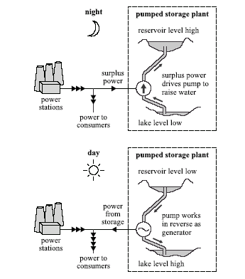 **[12 marks]**  
     
   The diagram below shows the principle of a hydroelectric pumped storage plant. During times when there is a low demand for electricity, the spare capacity of other power stations is used to pump water from the lake into the reservoir. The potential energy of the water is then converted into electricity when needed to satisfy peak demand

Other power

stations

Other power

stations

For this plant the water falls an average distance of 370 m between the reservoir and the generator. The mass of water stored in the reservoir when it is full is 1.0 x 1010 kg.

* 1. Show that the useful gravitational potential energy stored when the reservoir is full is about 4.0 x 1013  J.  
      **[2 marks]**
  2. Calculate the speed of the water as it reaches the generator assuming that no energy is lost as the water falls.  
      **[2 marks]**
  3. The pumped storage plant has four 100MW generators. Calculate the longest time, in hours, for which the stored energy alone could provide power at maximum output. Assume that all the stored gravitational potential energy can be converted into electrical energy.  
      **[3 marks]**
  4. Using the answer from c) above, what maximum income could the plant receive from electricity sales if the wholesale price of electricity is 10.5 cents per unit?  
      **[2 marks]**
  5. In practice not all the stored energy that is put into the system during the night can be retrieved as electrical energy during the day. State and explain how energy is lost in the system.  
      **[3 marks]**

1. 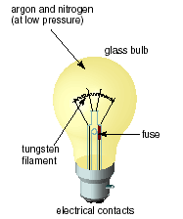 **[15 marks]**   
     
   In an incandescent bulb, the filament is made of a thin piece of tungsten metal, coiled to fit inside the bulb. When a current passes through the filament, it heats up and gives off visible light.   
   1. 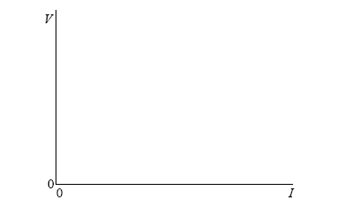On the axes below, draw a sketch-graph to show how the current (I) in the filament lamp varies with potential difference (V) as the switch is turned on and the voltage increases to a maximum. *(****Note****: this is a sketch-graph;**you do not need to add any values to the axes).*  
      **[2 marks]**
   2. Explain how the resistance of the filament is determined from the graph.  
       **[2 marks]**
   3. Explain whether the graph you have sketched indicates ohmic behaviour **or** non-ohmicbehaviour.  
       **[2 marks]**

A filament lamp operates at maximum brightness when connected to a 6.0 V supply. At maximumbrightness, the current in the filament is 120 mA.

* 1. Calculate the resistance of the filament when it is operating at maximum brightness.  
      **[2 marks]**
  2. If the wire that makes up the filament has a diameter of 1.6 x 10-5 m, calculate the length of the tungsten in the globe.  
      **[4 marks]**
  3. Suppose the tungsten wire was replaced by an identically sized copper wire. What would you observe when the light was switched on.  
      **[3 marks]**

1. **[16 marks]**  
     
   1. Explain the term *nucleon.*  
       **[1 mark]**
   2. Explain the term *nuclear binding energy*.  
       **[1 mark]**

The axes below show values of mass number (*A)* on the horizontal axis and average binding energy per nucleon (*E)* in MeV on thevertical axis. (Binding energy is taken to be a positive quantity).  
  
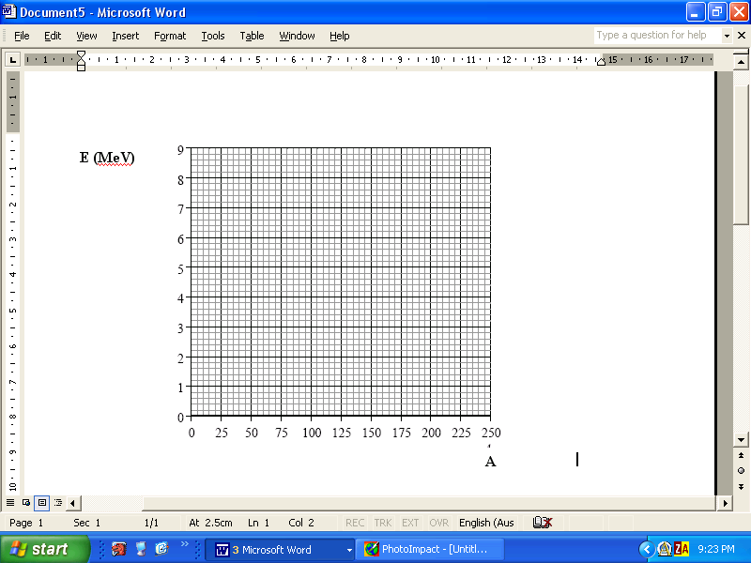

* 1. Without calculating the values, mark on the Eaxis above, the approximate position of
     1. the isotope 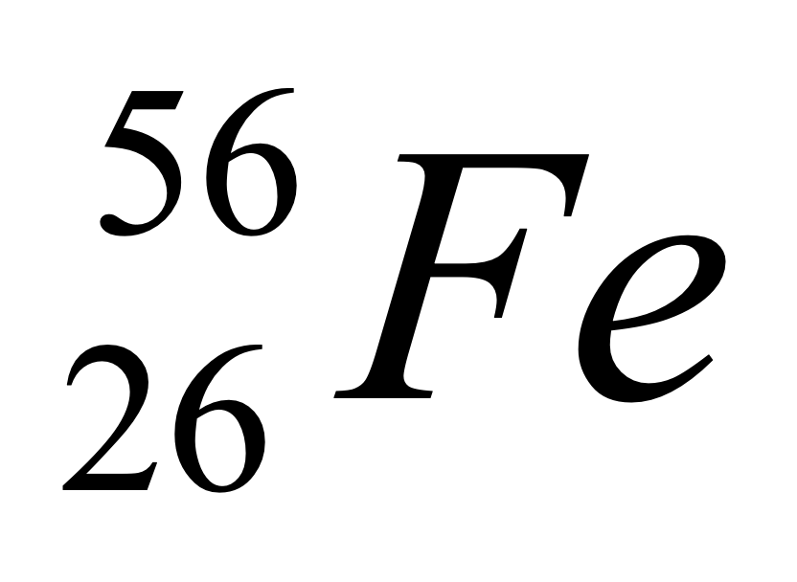(label this F). **[1 mark]**
     2. the isotope 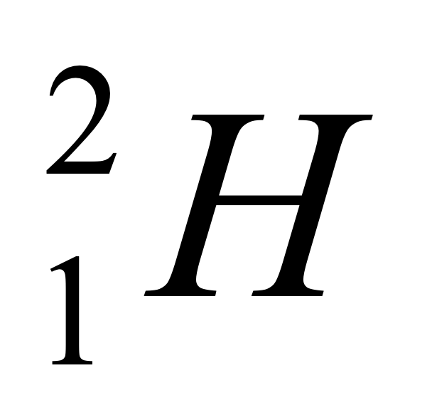 (label this H). **[1 mark]**
     3. the isotope 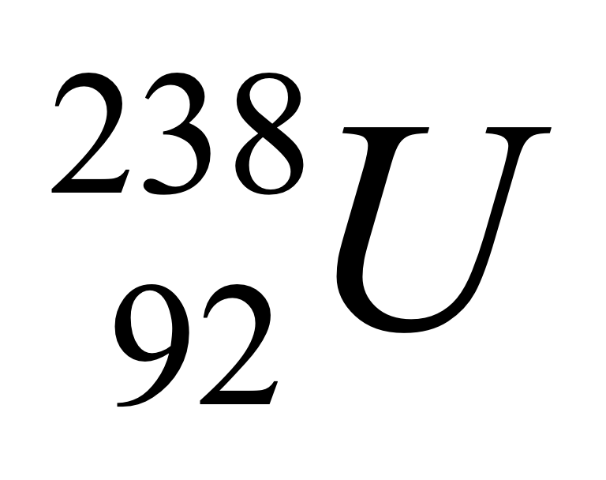 (label this U) **[1 mark]**
  2. Using the grid above, draw a graph to show the variation with mass number *A* of the average binding energy per nucleon *E*.  
      **[2 marks]**
  3. Use the data in the data sheet to determine the binding energy per nucleon of the isotope is 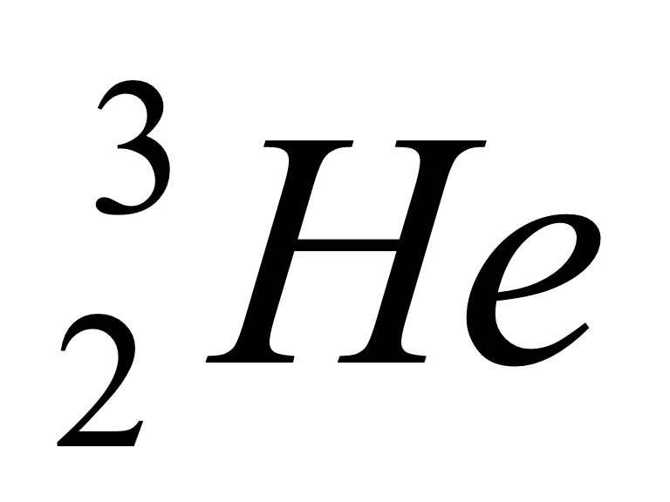.  
      **[3 marks]**

In the nuclear reaction   
  
 **+ ** ⇨ ** +** 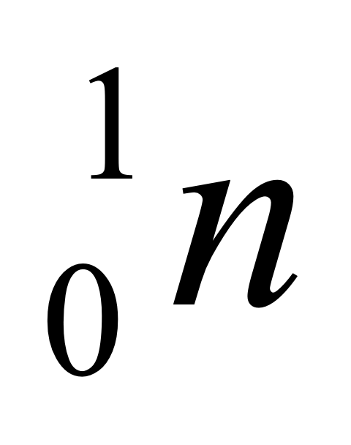   
  
  
energy is released.

* 1. State the name of this type of reaction.  
      **[1 mark]**
  2. Use your graph from d) above to explain why energy is released in this reaction.  
      **[3 marks]**
  3. Why are high temperatures needed to make the nuclear reaction above self-sustaining?  
      **[2 marks]**

1. **[19 marks]**  
     
   Paul conducts an experiment in the science laboratory in order to produce a heating curve. A quantity of crushed ice is removed from a freezer, dried with a paper towel, and placed in a calorimeter. Thermal energyis supplied to the ice at a constant rate and it is continually stirred. The temperature of the contents of the calorimeter is recorded every15 seconds. The graph below shows the variation with time *t* of the temperature T of the contents of thecalorimeter.

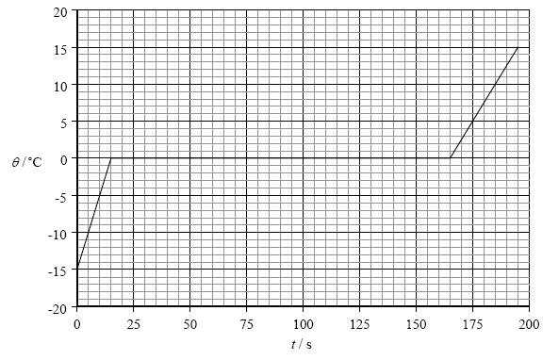

T ( oC)

t (s)

* 1. On the graph above, mark with an X, the data point on the graph at which all the ice has justmelted.  
      **[1 mark]**
  2. Explain, with reference to the energy of the molecules, the constant temperature region of thegraph.  
      **[4 marks]**
  3. The mass of the ice that Paul used was 0.25 kg. Use this data and data from the graph to determine the power of the heater.  
      **[4 marks]**
  4. From the data supplied determine the specific heat capacity of ice.  
      **[4 marks]**
  5. Why was it necessary for the ice to be continually stirred?  
      **[2 marks]**
  6. Why was the ice dried before it was placed in the calorimeter?  
      **[2marks]**
  7. Suppose that the ice had not been dried prior to being placed in the calorimeter. How would this have affected the value for the specific latent heat of fusion of ice that you calculated above? Explain.  
      **[2 marks]**

1. 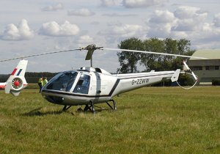**[15 marks]**

A helicopter such as the one shown at right has a mass of 5000 kg and is sitting on the ground with its engines idling, producing a lift force of 1.60 x 104 N.

**a.** Calculate the normal reaction force of the ground on the helicopter. **[2 marks]**

**b.** The pilot now increases the speed and tilt of the rotors, so that the lift force becomes 6.00 x 104 N. Calculate the upwards acceleration of the helicopter. **[3 marks]**

**c.** If the helicopter continues to accelerate at this rate, how long will it take to reach a height of 350m? **[2 marks]**

**d.** What will be its speed at 350m altitude? **[2 marks]**

Just as the helicopter reaches the height of 350m, a loose bolt dislodges from its undercarriage and eventually falls to the ground below.

1. In which direction does the bolt move initially? **[1 mark]**
2. Calculate how long the bolt takes to reach the ground. **[3 marks]**
3. With what speed does the bolt actually strike the ground?  
    **[2 marks]**
4. **[13 marks]**  
     
   Giles and Sally conduct an experiment in Physics to find the relationship between the angle of incidence *i* and the angle of refraction *r* of a light ray travelling from air to glass. Their experimental setup is shown below.  
     
   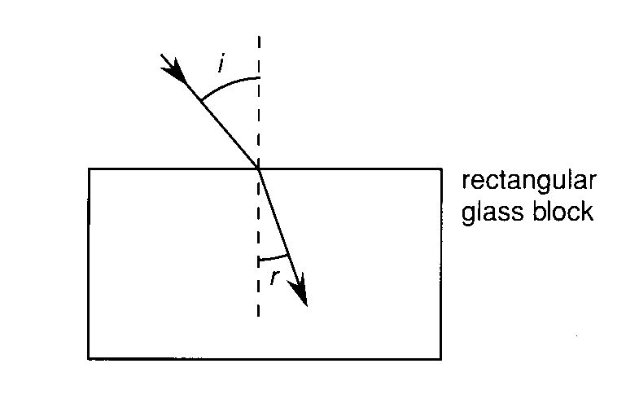  
     
   The results obtained are shown below.

|  |  |  |  |  |
| --- | --- | --- | --- | --- |
| **Angle of incidence (o)** | **Angle of refraction (o)** |  |  |  |
| **50.0** | **31.0** |  |  |  |
| **40.0** | **26.0** |  |  |  |
| **32.0** | **21.0** |  |  |  |
| **22.0** | **15.0** |  |  |  |
| **10.0** | **8.0** |  |  |  |

Theory tells us that for the situation above   
  
 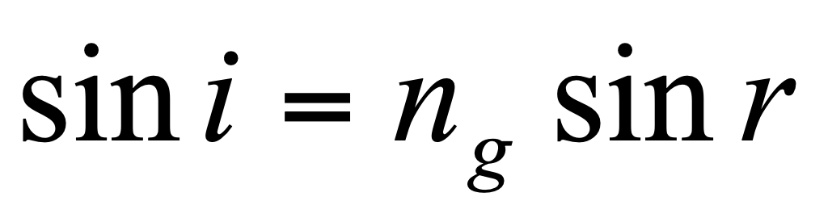  
  
where *ng* is the refractive index of the glass block.

* 1. Modify the data above so that you can plot a linear (straight line) graph of the data shown and enter this data into the table.  
      **[1 mark]**
  2. Using the included graph paper on the next page, plot the linear graph.  
      **[4 marks]**



* 1. Describe how you could determine the refractive index of the glass block from your graph   
      **[3 marks]**
  2. From the graph, determine the refractive index of the glass block?  
      **[2 marks]**
  3. Which set of readings is likely to yield the greatest percentage error  
      **[1 mark]**  
       
     1. Complete the ray diagram below to show the path of the light rays as it emerges from the glass block.  
         **[1 mark]**  
        
     2. What can you say about the direction of the emerging ray and the ray that is incident on the glass block?  
         **[1 mark]**

**SECTION C: Comprehension**

**Marks Allotted: 40 marks out of total of 200 marks (20%)**

### This section contains **TWO** questions. You should answer **BOTH** of the questions.

Read the following passages and answer the questions at the end of each. Candidates are reminded of the need for clear and concise presentation of answers. Diagrams (sketches), equations and/or numerical results should be included as appropriate.

**Question 1:**

Walk into almost any business office, and you'll probably find a photocopier ("copier") with a line of people waiting to use it. For most businesses, small or large, the copier has become standard equipment, much like having a desk to work at and a chair to sit in.

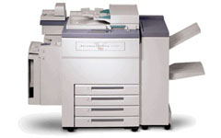

What happens inside the copier at this point is amazing! At its heart, a copier works because of one basic physical principle: **opposite charges attract**. As a kid, you probably played with static electricity and balloons. **On a dry winter day**, you can rub a balloon on your sweater and create enough static electricity in the balloon to create a noticeable force. For example, a balloon charged with static electricity will attract small bits of paper or particles of sugar very easily.

A copier uses a similar process.

* Inside a copier there is a special **drum**. The drum acts a lot like a balloon – you can charge it with a form of static electricity.
* Inside the copier there is also a very fine black powder known as **toner**. The drum, charged with static electricity, can attract the neutral toner particles.

There are three things about the drum and the toner that let a copier perform its magic:

* The drum can be **selectively** charged, so that only parts of it attract toner. In a copier, you make an “image” – in static electricity – on the surface of the drum. Where the original sheet of paper is black, you create static electricity on the drum. Where it is white you do not. What you want is for the white areas of the original sheet of paper to **NOT** attract toner. The way this selectivity is accomplished in a copier is with light – this is why it’s called a **photocopier**!
* Somehow the toner has to get onto the drum and then onto a sheet of paper. The drum selectively attracts toner. Then the sheet of paper gets charged with static electricity and it pulls the toner off the drum.
* The toner is **heat sensitive**, so the loose toner particles are attached (fused) to the paper with heat as soon as they come off the drum.

The **drum**, or belt, is made out of **photoconductive** material. Here are the actual steps involved in making a photocopy:

* The surface of the drum is charged to a charge of about +0.25 nC.
* An intense beam of light moves across the paper that you have placed on the copier’s glass surface. Light is reflected from white areas of the paper and strikes the drum below.
* Wherever a photon of light hits, electrons are emitted from the photoconductive atoms in the drum and neutralize the positive charges above. Dark areas on the original (such as pictures or text) do not reflect light onto the drum, leaving regions of positive charges on the drum’s surface.
* Black pigment called **toner** is then spread over the surface of the drum, and the pigment particles adhere to the positive charges that remain.
* A sheet of paper positively charged to about 0.1 nC then passes over the surface of the drum at a distance of 1.0 mm, attracting the beads of toner away from it.
* The paper is then heated and pressed to fuse the image formed by the toner to the paper’s surface.

* 1. What is meant by the term “**opposite charges attract**” ? **[2 marks]**
  2. Why is a “**dry winter day”** necessary to demonstrate static electricity?   
      **[2 marks]**
  3. Explain how toner can be attracted to the drum when the toner is neutral.   
      **[3 marks]**
  4. Explain what is meant by saying that a photocopier drum is selectively charged.   
      **[2 marks]**
  5. How many electrons need to be removed from the drum in order to produce a charge of 0.25 nC? **[3 marks]**
  6. How are regions of positive charge produced on the drum?   
      **[3 marks]**
  7. Estimate the force of repulsion that would exist between the positively charged paper going into the drum and the drum itself. **[4 marks]**
  8. In actual fact, the force is much less that you have calculated in g). Why would this be the case?  
      **[3 marks]**

**THIS PAGE HAS BEEN LEFT INTENTIONALLY BLANK**

**Question 2:**

Until relatively recently, "huge screen TV" meant pretty much one thing: a rear-projection cathode ray tube (CRT) set. But if you go to the electronics store today, you'll see several big screen options - plasma, liquid crystal display (LCD) and digital light processing (DLP) television.

DLP sets are an attractive option because they're a lot cheaper than flat panel plasma and LCD sets of the same size. They also have a better picture and are less bulky than conventional CRT sets.

Pixels and Mirrors  
At the heart of the DLP system is a **digital micromirror device** (DMD). The DMD is tiny, you could hold it in the palm of your hand. But if you could get a close-up look at one while it was working, what you would see would resemble a photo mosaic.

|  |
| --- |
| Photo courtesy Michael Jastremski for [openphoto.net](http://electronics.howstuffworks.com/framed.htm?parent=dlp.htm&url=http://www.openphoto.net/gallery/image.html?image_id=8403) **Colour Blue Mountain Flower Mosaic** |

When you look closely at a photo mosaic, you see a group of tiny, square photographs. But when you step away from the mosaic, the photos blend together to create a larger image. This is what happens with a DMD, except that it uses light instead of tiny photographs. If you looked at it very closely, you would only see tiny, square mirrors reflecting light. But, from far away (or when the light is projected on a screen), you would see a picture.

|  |
| --- |
| Photo courtesy [Texas Instruments](http://electronics.howstuffworks.com/framed.htm?parent=dlp.htm&url=http://www.dlp.com) **The leg of an ant rests on this DMD mirror array** |

A DMD contains as many as two million microscopic mirrors, and each mirror corresponds to one pixel of the finished picture. The aluminium mirrors are sixteen microns square and weigh only a few millionths of a gram. Each one is attached to a yoke and a hinge that moves the mirrors to the on and off positions.

In addition to the mirrors, the DMD unit includes:

* A CMOS DDR SRAM chip, which is a memory cell that will electrostatically cause the mirror to tilt to the on or off position.
* A heat sink
* An optical window, which allows light to pass through while protecting the mirrors from dust and debris

Creating a Picture  
Before any of the mirrors switch to their on or off positions, the chip rapidly:

* Decodes the incoming signal
* Converts interlaced data to progressive data
* Sizes the picture to fit the screen
* Makes any necessary adjustments to the picture, including brightness, sharpness and colour quality
* Converts colour information to red, green and blue (RGB) format

It then digitally relays all the information to the mirrors. If the size of the image contains fewer pixels than the DMD supports, then the chip simply ignores the unneeded mirrors.

When the set is off, all of the mirrors are flat. When someone turns the set on and the chip begins transmitting the signal, the mirrors flip back and forth thousands of times per second. They move between +10° and -10° in older DMDs, or between +12° and -12° in newer DMDs. Newer DMDs also use "dark metal" on the aluminium mirrors whose function is similar to the dark pigments in the retina of the human eye.

Mirrors in the on position reflect the light through a projection lens and onto the screen. By varying the length of time that the mirrors point toward the projection lens, the DMD creates up to 1,024 shades of gray.

The grey pixels combine on the screen to create a fully digital monochrome image

Adding Colour   
To add colour to the picture, the DLP system uses a **colour wheel**.

The colour wheel does exactly what its name implies. It's a transparent, spinning wheel with coloured segments. The light passing through each section turns the colour of the segment.

The system's processor synchronizes the spinning of the wheel with the action of the mirrors. Together, the DMD and the colour wheel can create 256 shades of each primary colour.

Each pixel of light on the screen is red, green or blue at any given moment. The DLP technology relies on the viewer's eyes to blend the pixels into the desired colours of the image. With this system, the DLP is capable of creating 16 million colours.

|  |
| --- |
| The Rainbow Effect  Most people's eyes do such a good job of blending colours that individual red, green and blue pixels go unnoticed. However, some people experience a "rainbow effect" when watching a DLP projection, especially when they change their focus from one part of the image to another. They may see the individual component colour s or may just sense a shimmering in the picture. This happens only in DLP systems that use a segmented colour wheel, not in systems that use one DMD for each primary colour .  A number of home theatre systems use colour wheels with additional segments to try to reduce the rainbow effect. Many use wheels with two segments of each colour. Some systems also add a dark green colour segment to improve the colour quality. Another option, **sequential colour recapture** (SCR), uses primary colours arranged in a spiral instead of in segments. |

Once the DMD has created a picture out of light and the colour wheel has added colour , the light passes through a lens. The lens projects the image onto the screen.

Quality and Reliability  
Considering its size and its vast number of parts -- as many as two million microscopic, moving mirrors -- it seems unreasonable to expect that a DLP system would actually work. Instead, it seems more likely that the parts would break or the mirrors would get stuck, especially since each part can make billions of movements and contacts during its lifetime.   
  
So what keeps a DMD from breaking or falling apart? There are three major components that keep them together:

* Hinges.
* An anti-stick layer and spring-like contacts.
* Hermetic seals.

|  |
| --- |
| Photo courtesy [Texas Instruments](http://electronics.howstuffworks.com/framed.htm?parent=dlp.htm&url=http://www.dlp.com) **A DMD Chip is small but sturdy** |

* 1. What does the author mean by saying that the mirrors are made to tilt electrostatically?  
      **[2 marks]**
  2. Newer DMDs can tilt through a greater angle than older DMDs. How would this affect the image produced?  
      **[2 marks]**
  3. What would be the advantage of the “dark metal” used in newer DMDs   
      **[2 marks]**
  4. What type of lens is the projection lens and what type of image would it produce?  
      **[2 marks]**
  5. How are shades of gray are produced by the DMD ?  
      **[3 marks]**
  6. What colours make up the spinning wheel?  
      **[2 marks]**
  7. How might the DMD produce the colour yellow?  
      **[2 marks]**
  8. Describe how the rainbow effect occurs?   
      **[2 marks]**
  9. Describe how the three major components that keep the DMDs together work

**[2 marks]**

ACKNOWLEDGEMENTS

## SECTION C

**Question 1: How photocopiers work in http://electronics.howstuffworks.com/photocopier.htm**

**Question 2: How DLP sets work in http://electronics.howstuffworks.com/dlp.htm**

**END OF PAPER**